Guidelines for Publications:
Speakers are invited to submit a text for publication in the Conference Selections (within a 1500-word limit, with up to 10 references).
It should be preceded by the full name of the author (including the patronymic and the academic title, if applicable), the full name of the place of employment (including the city and country), the e-mail address of each author, mailing address and telephone number (one per article).
The following information should be provided in both English and Russian: the title of the publication, the name of the author, the name of the educational institution, an abstract (up to 130 words) and a list of key words (separated by a semi-colon).
The texts should be typed in 14 point Times New Roman. References should be typed in 12 point Times New Roman as a numbered list and presented in accordance with the Russian standards of references (see Fig. 1 and 2 below). Pages should not be numbered, no page/section breaks, tabs, line breaks, hyphens for word breaks or extra spaces (for example, for indented lines) are to be used. In case the text contains colour diagrams, highlights, table backgrounds, figures, please replace the colour with the shade of grey contrasting with the text in the foreground. Texts should be attached to e-mails as *.doc, *.docx or *.rtf files, file names beginning with the author’s last name). The attachments should not contain macros. The editors reserve the right to make editorial changes in any manuscript submitted.
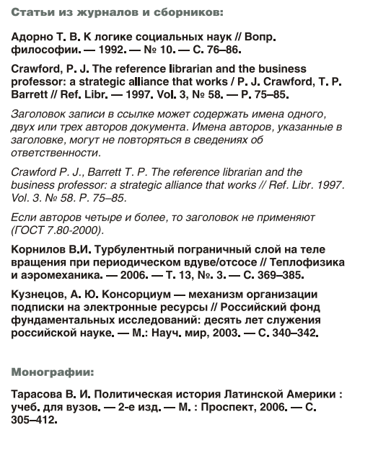
Fig. 1

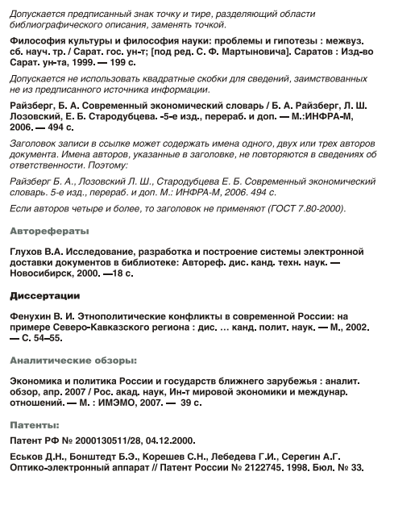
Fig. 2

